**CONTROL**

**STATEMENTS**

SARTHAK SANAY

**(1) AIM:-**

To write a program in C to determine whether a number given by the user is even or odd using if-else statement.

**CODE:-**

**#include <stdio.h>**

**int main()**

**{**

**int n;**

**printf("Enter a number: ");**

**scanf("%d", &n);**

**if(n%2==0)**

**printf("%d is an even number.", n);**

**else**

**printf("%d is an odd number.", n);**

**return 0;**

**}**

**OUTPUT SCREEN:-**

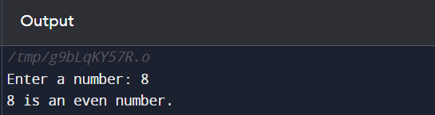

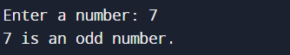

**(2) AIM:-**

To implement a calculator in C using switch-case statements.

**CODE:-**

**#include <stdio.h>**

**int main()**

**{**

**int c, n1, n2;**

**printf("Enter 1 for addition, 2 for multiplication, 3 for division, and 4 for subtraction: ");**

**scanf("%d", &c);**

**printf("Enter 1st number: ");**

**scanf("%d", &n1);**

**printf("Enter 2nd number: ");**

**scanf("%d", &n2);**

**switch(c)**

**{**

**case 1:**

**printf("Sum of %d and %d is %d", n1, n2, n1+n2);**

**break;**

**case 2:**

**printf("Product of %d and %d is %d \n\n", n1, n2, n1*n2);**

**break;**

**case 3:**

**printf("Quotient of %d and %d is %d \n\n", n1, n2, n1/n2);**

**break;**

**case 4:**

**printf("Difference between %d and %d is %d \n\n", n1, n2, n1-n2);**

**break;**

**default:**

**printf("Enter correct number as input for choice.");**

**break;**

**}**

**return 0;**

**}**

**OUTPUT SCREEN:-**

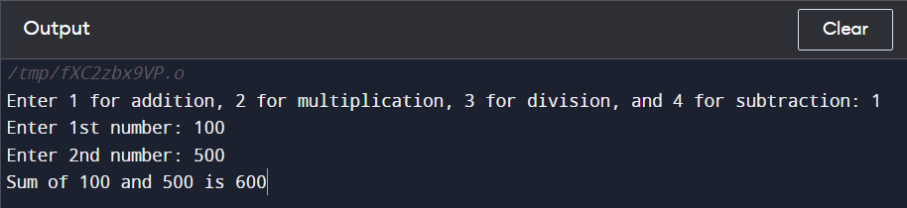

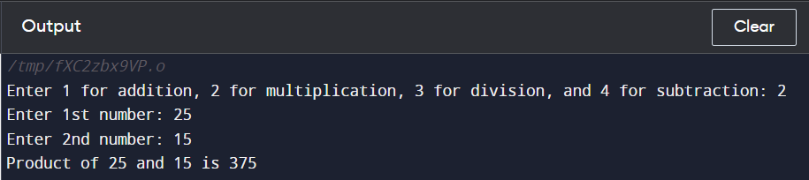

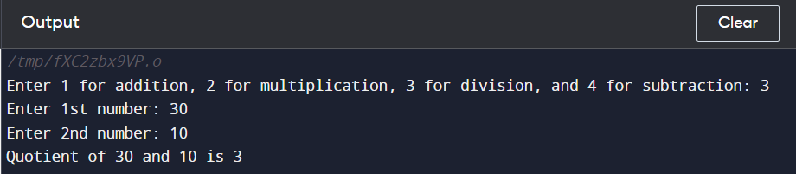

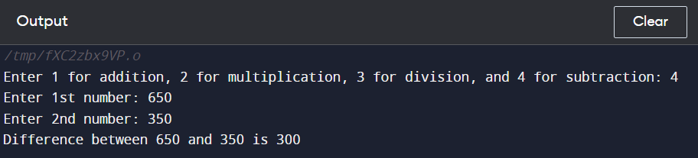

**(3) AIM:-**

Topractice printing all 10 patterns using loops (while, do-while, for).

**PATTERN 1:- (using for loop)**

**#include <stdio.h>**

**int main()**

**{**

**int i, j, N;**

**printf("Enter value of N: ");**

**scanf("%d", &N);**

**for(i=1; i<=N; i++)**

**{**

**for(j=1; j<=i; j++)**

**{**

**printf("*");**

**}**

**printf("\n");**

**}**

**return 0;**

**}**

**OUTPUT 1:-**

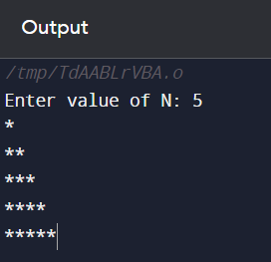

**PATTERN 2:- (using while loop)**

**#include <stdio.h>**

**int main()**

**{**

**int i=1, j, N;**

**printf("Enter value of N: ");**

**scanf("%d", &N);**

**while(i<=N)**

**{**

**j=1;**

**while(j<=i)**

**{**

**printf("%d", j);**

**j++;**

**}**

**printf("\n");**

**i++;**

**}**

**return 0;**

**}**

**OUTPUT 2:-**

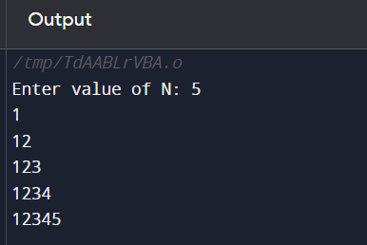

**PATTERN 3:-**

**#include <stdio.h>**

**int main()**

**{**

**int i, j, N, c=1;**

**printf("Enter value of N: ");**

**scanf("%d", &N);**

**for(i=1; i<=N; i++)**

**{**

**for(j=1; j<=i; j++)**

**{**

**printf("%d", c);**

**c++;**

**}**

**printf("\n");**

**}**

**return 0;**

**}**

**OUTPUT 3:-**

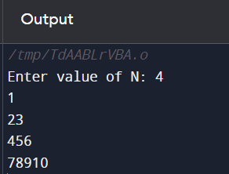

**PATTERN 4:-**

**#include <stdio.h>**

**int main()**

**{**

**int i, j, N;**

**printf("Enter the value of N: ");**

**scanf("%d", &N);**

**for(i=1; i<=N; i++)**

**{**

**for(j=i; j<=N; j++)**

**{**

**printf("*");**

**}**

**printf("\n");**

**}**

**return 0;**

**}**

**OUTPUT 4:-**

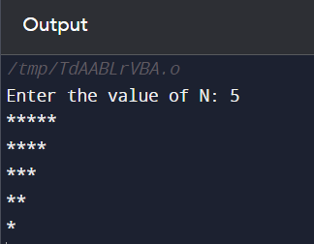

**PATTERN 5:- (Square pattern using for loop)**

**#include <stdio.h>**

**int main()**

**{**

**int i, j, N;**

**printf("Enter the value of N: ");**

**scanf("%d", &N);**

**for(i=1; i<=N; i++)**

**{**

**for(j=1; j<=N; j++)**

**{**

**if(i==1 || j==1 || j==N || i==N)**

**printf("*");**

**else**

**printf(" ");**

**}**

**printf("\n");**

**}**

**return 0;**

**}**

**OUTPUT 5:-**

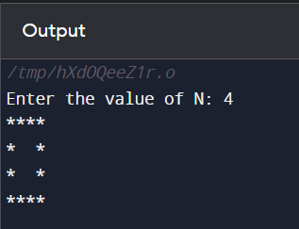

**PATTERN 6:-**

**#include <stdio.h>**

**int main()**

**{**

**int i, j, N, c;**

**printf("Enter the value of N: ");**

**scanf("%d", &N);**

**for(i=1; i<=N; i++)**

**{**

**c= 1;**

**for(j=i; j<=N; j++)**

**{**

**printf("%d", c);**

**c++;**

**}**

**printf("\n");**

**}**

**return 0;**

**}**

**OUTPUT 6:-**

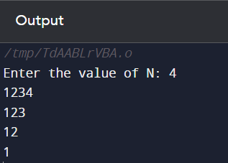

**PATTERN 7:-**

**#include <stdio.h>**

**int main()**

**{**

**int i, j, N;**

**printf("Enter the value of N: ");**

**scanf("%d", &N);**

**for(i=1; i<=N; i++)**

**{**

**for(j=N; j>=1; j--)**

**{**

**if(j>i)**

**printf(" ");**

**else**

**printf("*");**

**}**

**printf("\n");**

**}**

**return 0;**

**}**

**OUTPUT 7:-**

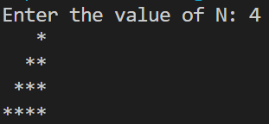

**PATTERN 8:-**

**#include <stdio.h>**

**int main()**

**{**

**int i, j, N, c;**

**printf("Enter the value of N: ");**

**scanf("%d", &N);**

**for(i=1; i<=N; i++)**

**{**

**c= 1;**

**for(j=N; j>=1; j--)**

**{**

**if(j>i)**

**printf(" ");**

**else**

**{**

**printf("%d", c);**

**c++;**

**}**

**}**

**printf("\n");**

**}**

**return 0;**

**}**

**OUTPUT 8:-**

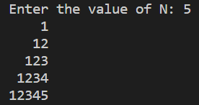

**PATTERN 9:- (using do-while loop)**

**#include <stdio.h>**

**int main()**

**{**

**int i=1, j, N;**

**printf("Enter the value of N: ");**

**scanf("%d", &N);**

**do**

**{**

**j= 1;**

**do**

**{**

**if (j>=i)**

**printf("*");**

**else**

**printf(" ");**

**j++;**

**} while (j<=N);**

**printf("\n");**

**i++;**

**} while (i<=N);**

**return 0;**

**}**

**OUTPUT 9:-**

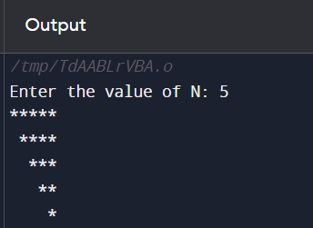

**PATTERN 10:-**

**#include <stdio.h>**

**int main()**

**{**

**int i, j, N, c=1;**

**printf("Enter the value of N: ");**

**scanf("%d", &N);**

**for(i=1; i<=N; i++)**

**{**

**for(j=1; j<=N; j++)**

**{**

**if(j>=i)**

**{**

**printf("%d", c);**

**c++;**

**}**

**else**

**printf(" ");**

**}**

**printf("\n");**

**}**

**return 0;**

**}**

**OUTPUT 10:-**

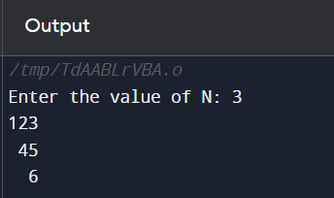

**(4) AIM:-**

To implement a program in C to find the factorial of a number given by the user using iterative approaches (loops).

**CODE:-**

**#include <stdio.h>**

**int main()**

**{**

**int n, p=1;**

**printf("Enter a number: ");**

**scanf("%d", &n);**

**for(int i=n; i>=1; i--)**

**{**

**p= p*i;**

**}**

**printf("Factorial of %d is %d", n, p);**

**return 0;**

**}**

**OUTPUT SCREEN:-**

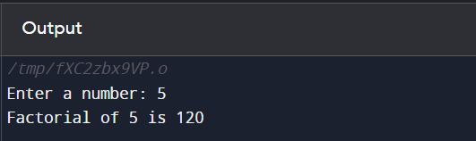

**(5) AIM:-**

To write a program in C to generate the Fibonacci series up to a specified number of terms by the user using a loop.

**CODE:-**

**#include <stdio.h>**

**int main()**

**{**

**int n;**

**printf("Enter the number of terms: ");**

**scanf("%d", &n);**

**printf("Fibonacci Series:-\n");**

**int a=0, b=1, c=a+b; // initializing the first three terms**

**printf("%d\t%d\t",a, b);**

**for(int i=3; i<=n; i++)**

**{**

**printf("%d\t",c);**

**a=b;**

**b=c;**

**c= a+b;**

**}**

**return 0;**

**}**

**OUTPUT SCREEN:-**

